FPGA XADC Voltmeter: Basys 3
  - VHDL based photoresistor voltage measurement, digital filtering, and real time display
https://github.com/harolu44-cpu/basys3-xadc-photoresistor-voltmeter

Overview
I designed and implemented a digital voltmeter using a Basys 3 and the built in XADC in the Artix-7 to measure a analog voltage generated by a photoresistor voltage divider. The XADC produces a 12-bit sample that I then processed in VHDL, averaged it out every 16 samples to increase accuracy, convert the readings given into volts and then display it on the seven-segment display on the Basys 3 board. The filtered and unfiltered were then compared to a conventional digital multimeter to verify the design.
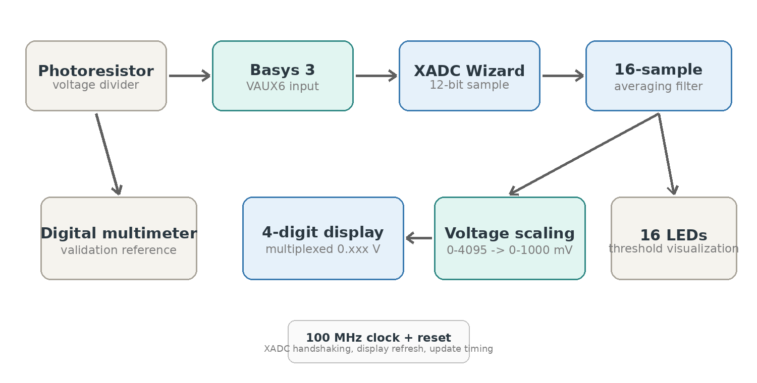

Hardware
The analog input is built on a breadboard using a GL5528 photoresistor and conventional resistors to form a voltage divider. The output of this divider was then connected to the Basys 3 positive analog input VAUX6. The XADC then handles the conversion interface and the VHDL logic handles the sample, filtering, LED threshold, and seven-segment display.

Components:
- Basys 3
- GL5528 photoresistor
- 10kΩ and 1KΩ
- Digital multimeter
- Jumper wires

Build Process

1. Circuit
I built a photoresistor voltage divider on a bread board so that the change in light level produces a changing analoge voltage you can see through the Basys 3 seven-segment display later checked with a digital multimeter.

2. XADC Configuration and Sampling Capture
I used the XADC Wizard Vivado provides and connected the analog channel VAUX6. The design uses a read after end of conversation method which waits for the data ready signal before taking the 12-bit ADC sample. The reason this was used is to have a cleaner and more synchronized XADC conversion.

3. VHDL Structure
The entity Top defines the 100 MHz clock, reset, XADC inputs, 16 LEDs, seven-segment outputs, anodes and decimal point. The component declaration and port map connect the generated XADC IP which Vivado provides with the rest of the design. These are shown in the next page.
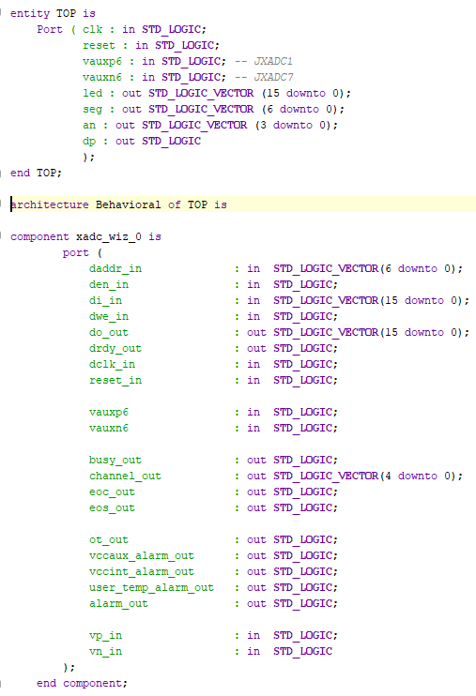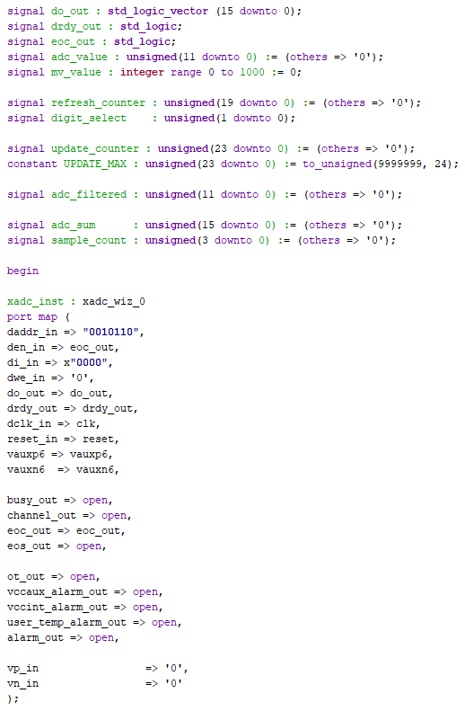

4. Averaging Filter
To make the seven-segment display more stable I added a 16-sample averaging filter. Each 12-bit sample is accumulated in a sum of 16 and then is averaged out and stored in the adc_filtered to be output after the conversion to volts. After this has happened, they are then reset to average the next group of samples.

5. ADC Counts to Volts
The filtered ADC count is scaled from the SADC 0-4095 range into 0-1 volt using mv_value <= ((to_integer(adc_filtered)*1000)/4095). The +2047 provides rounding before division so the result displayed is closer to the value expected.

6. Led and Seven-Segment Display
The 16 LEDs was the first part of this project worked on to check if the XADC was reading voltage to begin with and was left in the final project to have another way of visualizing it. While we included a decimal point in the seven-segment display because what was displayed was in mV a example is 0.340 mV. Code shown on next page.
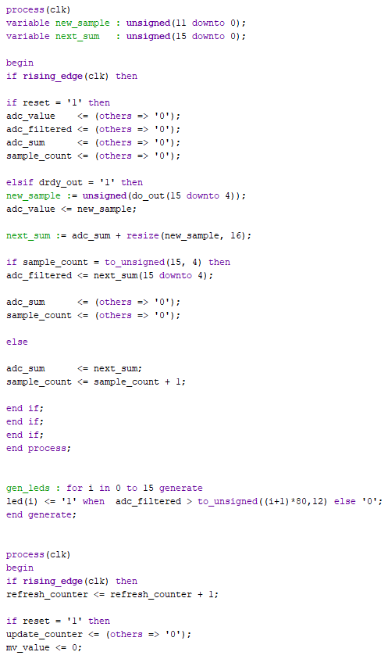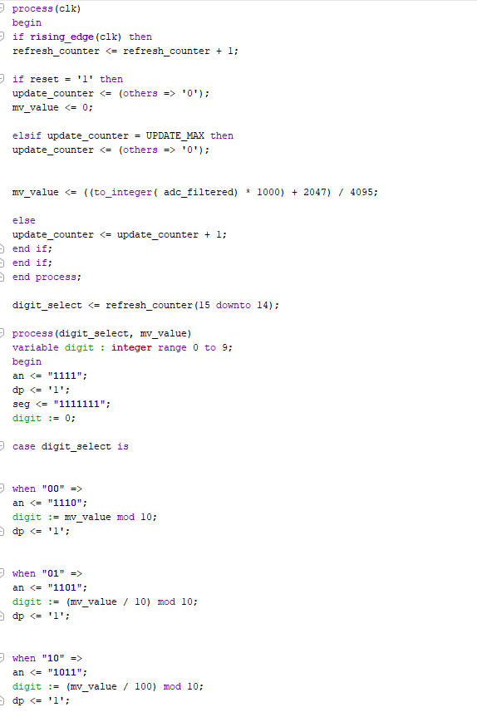

Pin Mapping / Constrains
For the pin mapping and constrains these were taken of the Basys 3 data sheet and was done using the pin mapping built into the Vivado software. Shown on the next page.
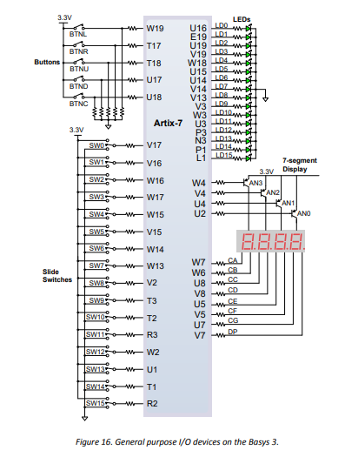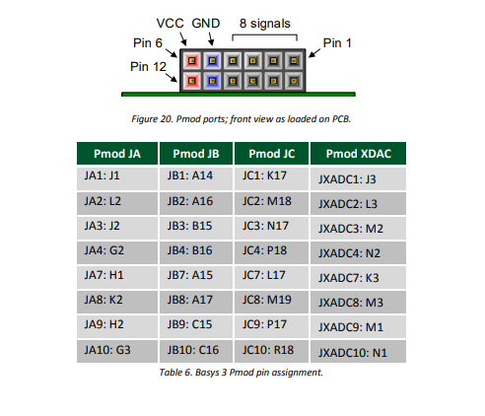
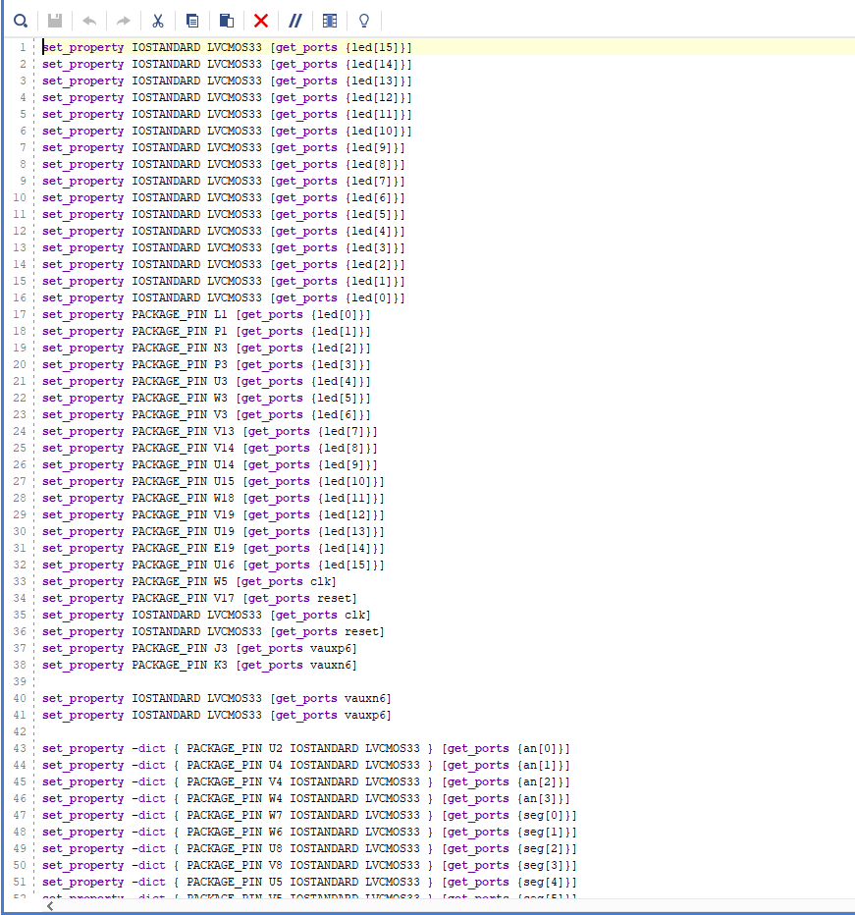

Results
The results was better than expected when compared to a conventional multimeter coming withing 0.010-0.020 of each other for the duration of the test which can be found on youtube https://www.youtube.com/shorts/ZjS7KwpbWkc?si=Oeiirqwa2CuMr34I.

Key Skills Demonstrated
- VHDL RTL design
- XILINX Artix-7 XADC configuration and signal interfacing
- 12-bit ADC data handling, scaling, rounding, and digital filtering
- Seven-segment display and LED output logic
- Vivado XDC constraints, pin mapping, and FPGA implementation
- Hardware validation using a breadboard circuit and digital multimeter
- Git / Sourcetree project organization and reproducible Vivado setup

Possible Next Steps
- Add gain/offset calibration using known voltages and multimeter reference
- Make the averaging length selectable using buttons or switches to quicken or slow the response time
- Stream the data that was taken from the XADC and stream it over UART for plotting and data logging
- Add VHDL testbench for processing logic

